

CLOUD COMPUTING LAB
BSE ( V-B )

Submitted By:
Musfira Farooq
Roll No:
2023-BSE-045
Submitted To:
Sir Muhammad Shoaib

LAB 08
AWS: Account Setup, IAM, VPC Inventory, EC2, Docker & Gitea

Task 1
Create an AWS account and enable UAE (me-central-1)
- AWS signup page:
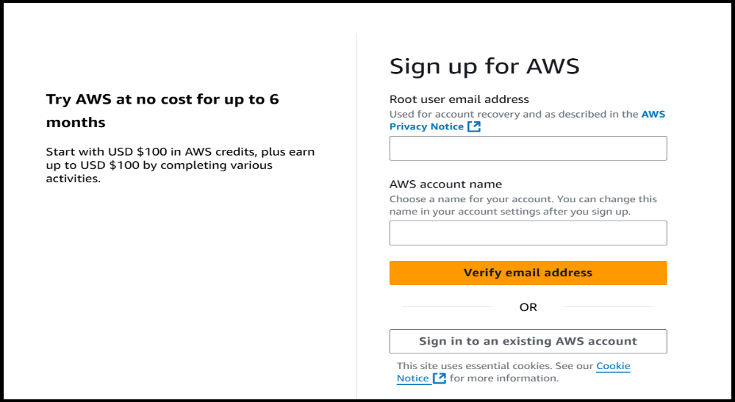
- Root user signed in:

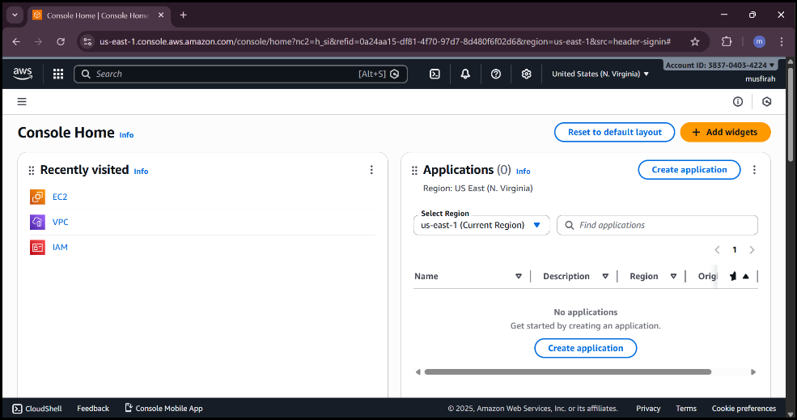
- Enable region me-central-1:
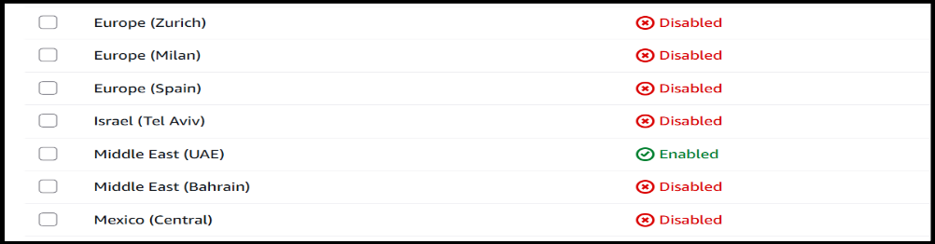
- task1 summary:
Task 2
Create IAM Admin and Lab8User with console access
- open iam console:
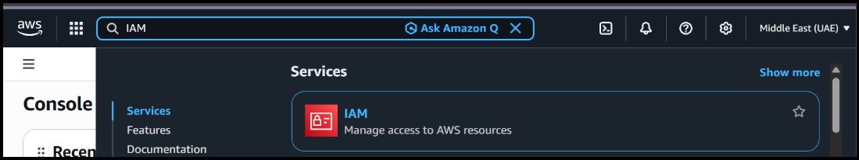
- admin create confirmation:
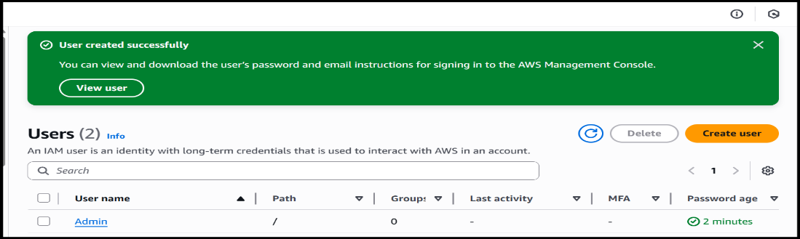
- admin csv and signin url:
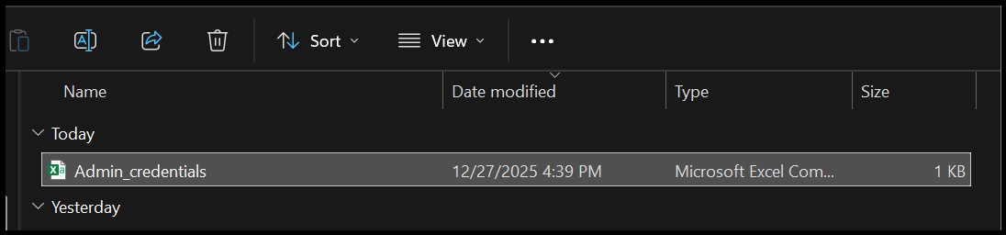
- admin console after login:
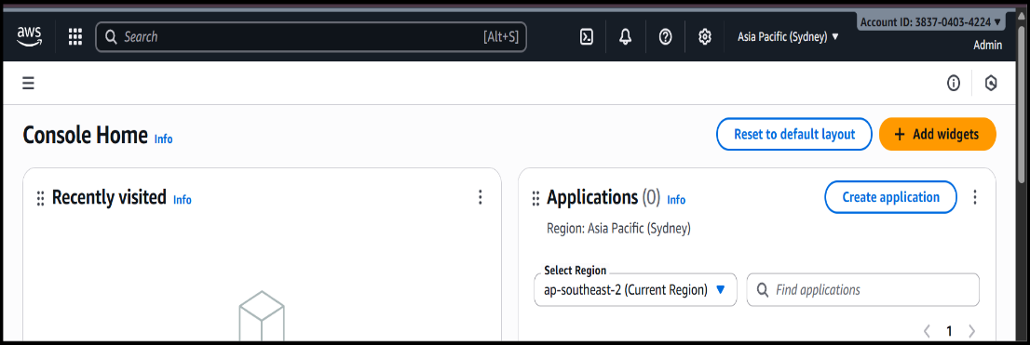
- create lab8user and csv:
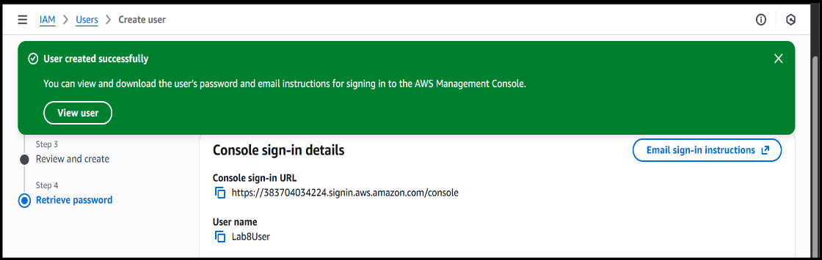
- lab8user csv saved:
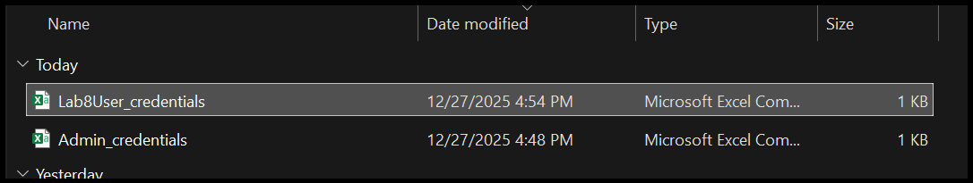
- lab8user logged in:
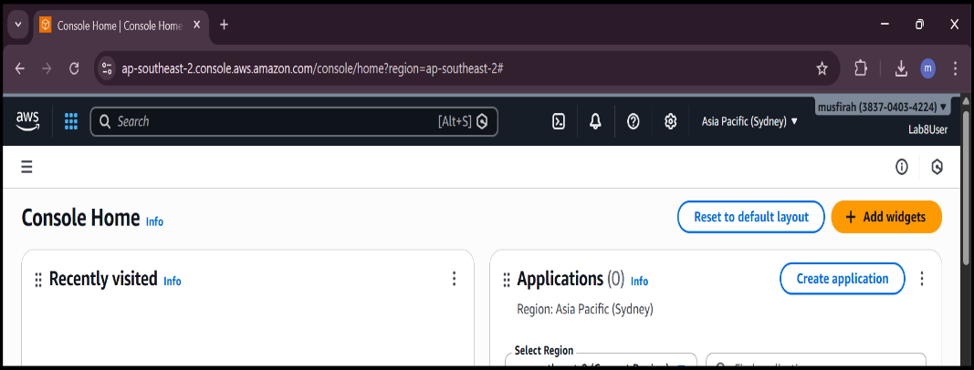
- task2 summary:
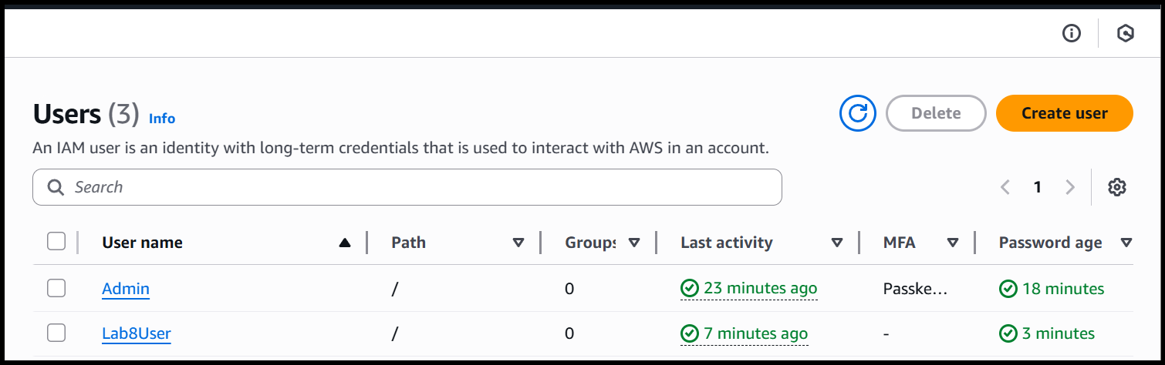
Task 3
Inspect VPC resources (in UAE me-central-1)
- open_vpc_console:
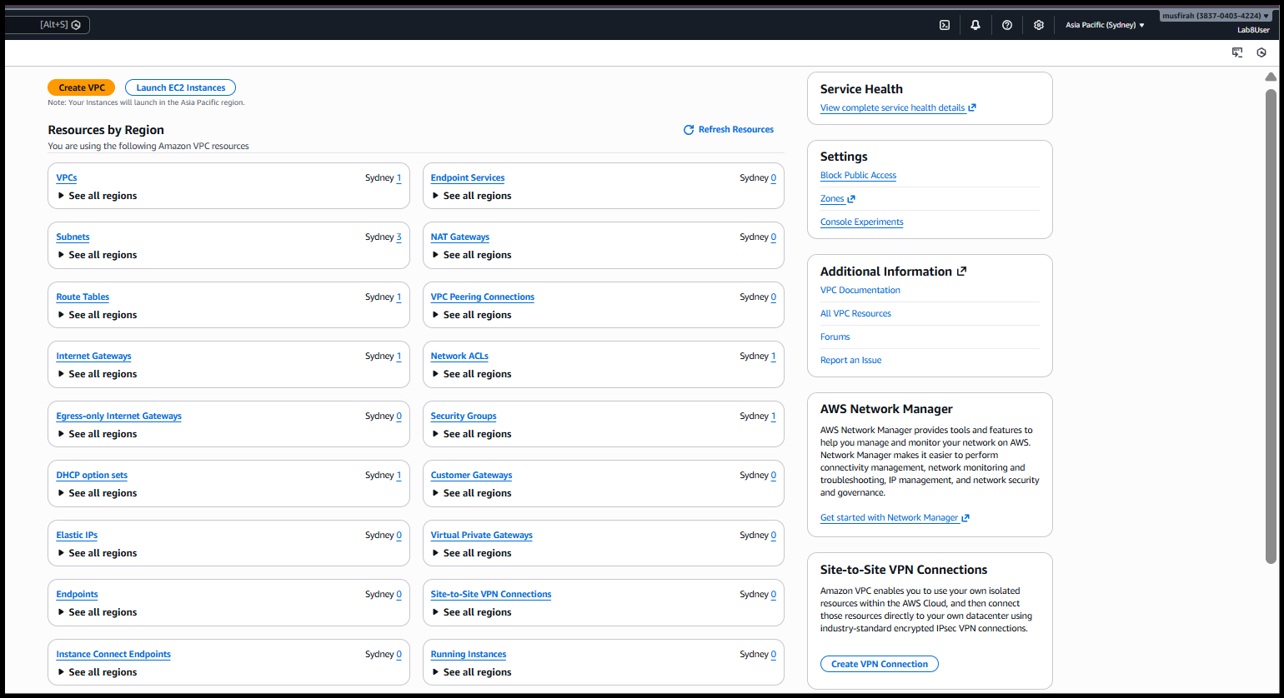
- vpcs_list:
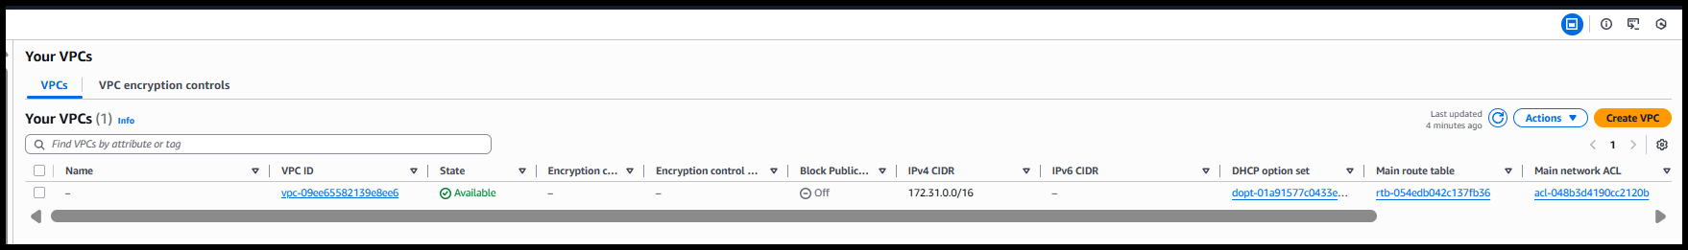

- subnets_list:
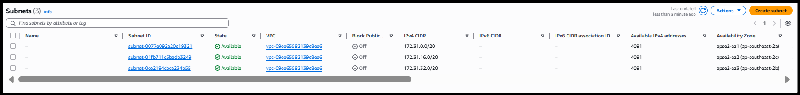
- route_tables_list:
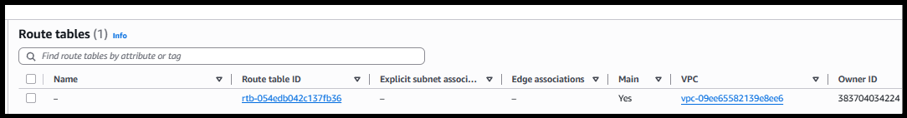

- network_acls_list:
- summary:
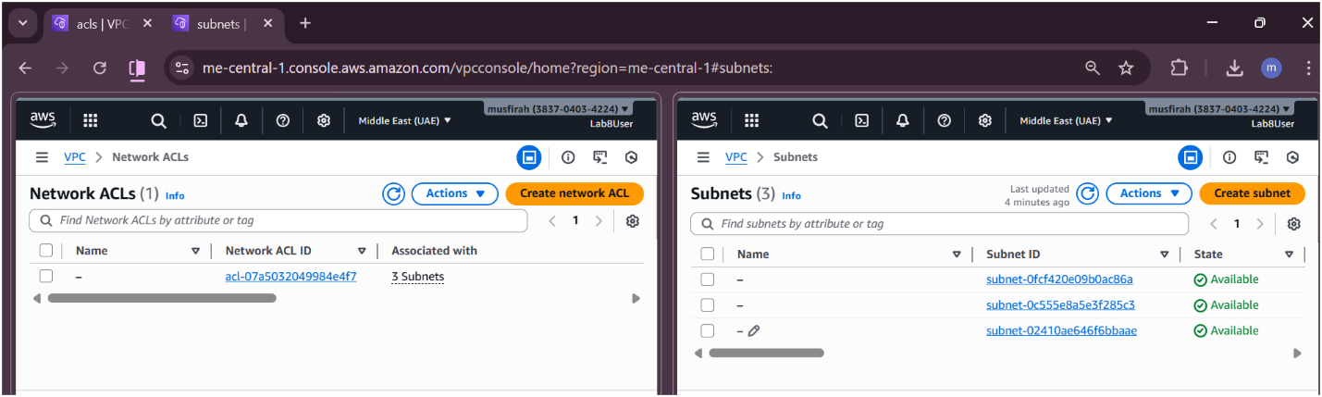
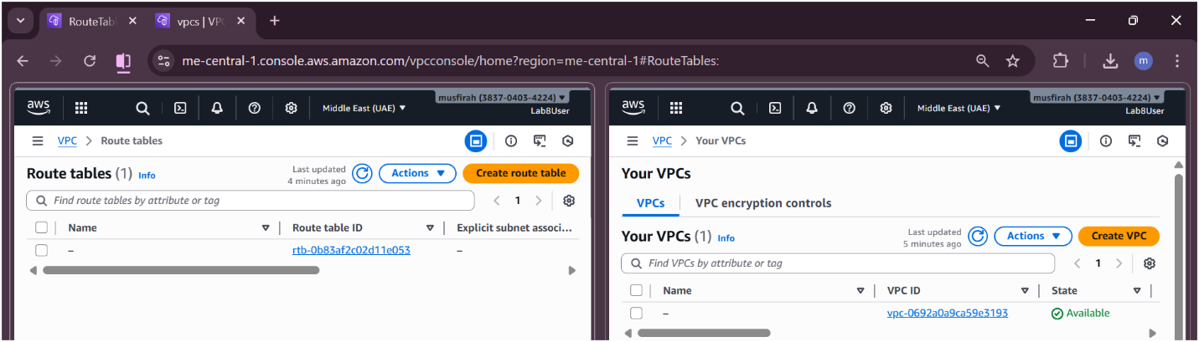
Task 4
Launch EC2, SSH, install Docker & Docker Compose, deploy Gitea
- Open EC2 Console

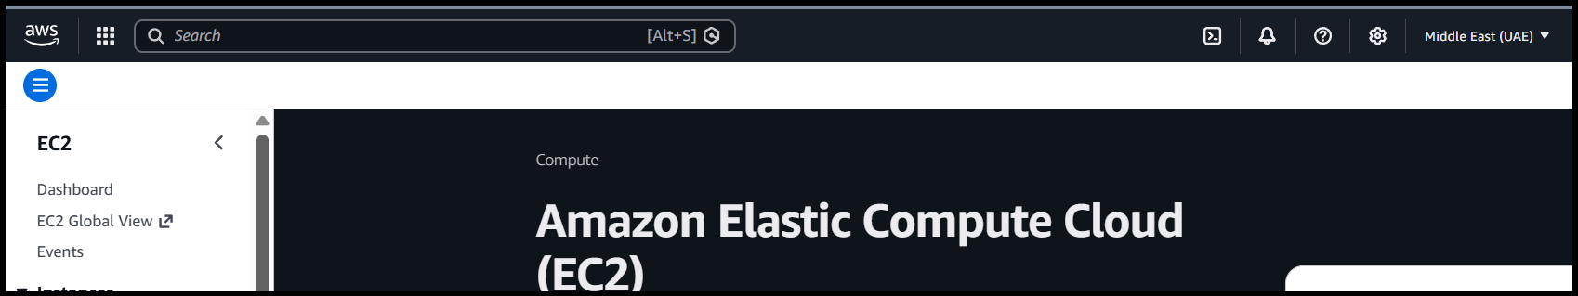
- Launch Instance Config

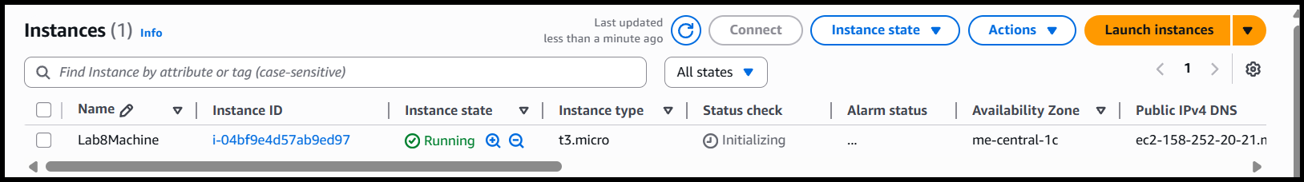
- Keypair Download

- Instance Running Console
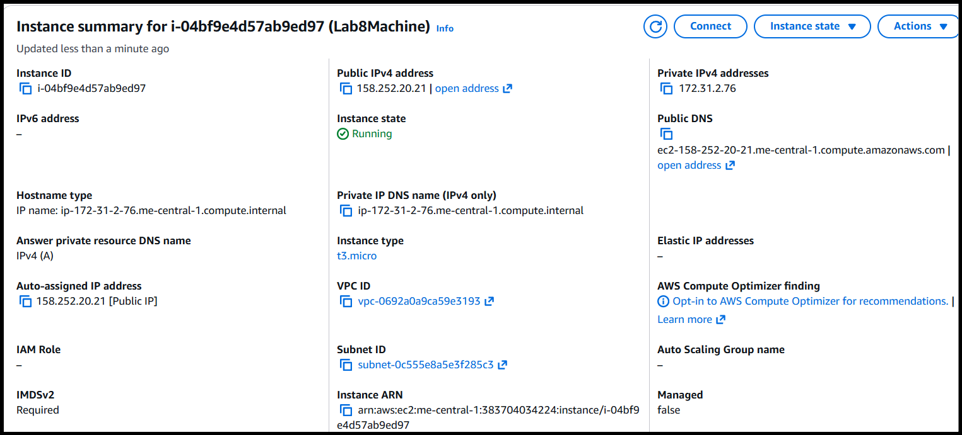
- SSH From Windows To EC2
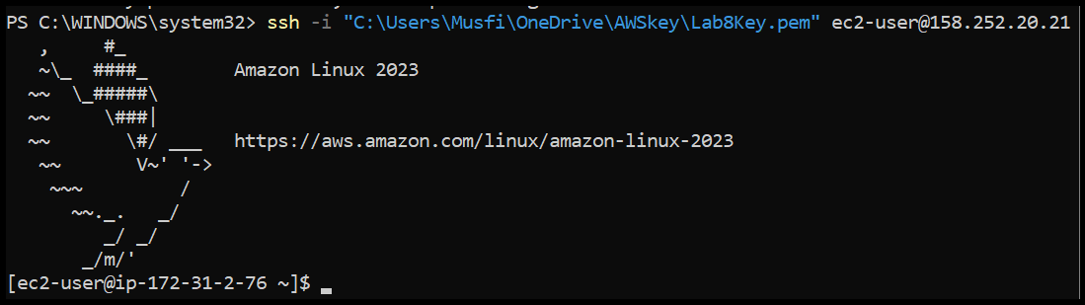
- EC2 Install Docker Compose Started
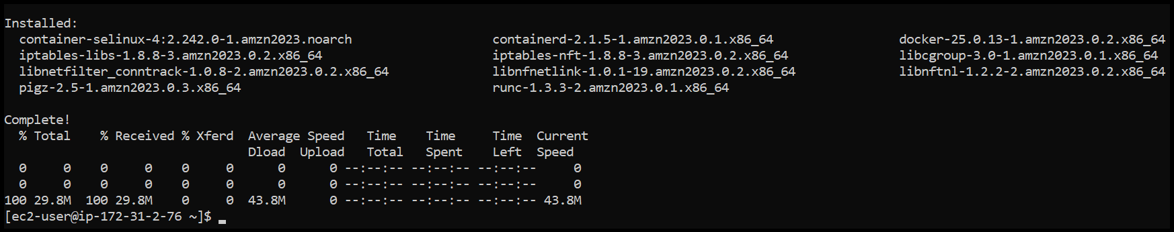
- Vim Compose YAML Paste
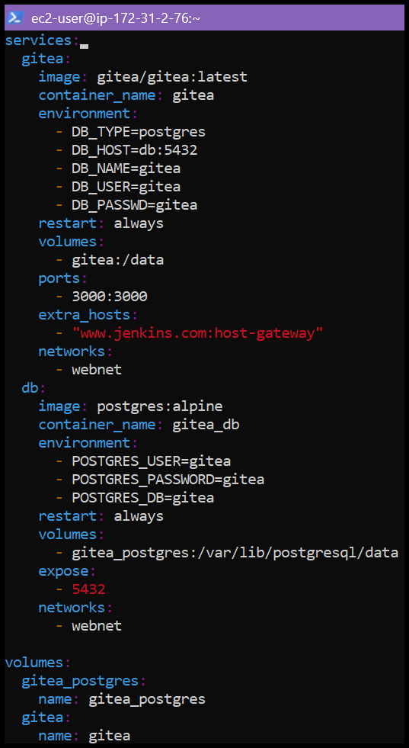
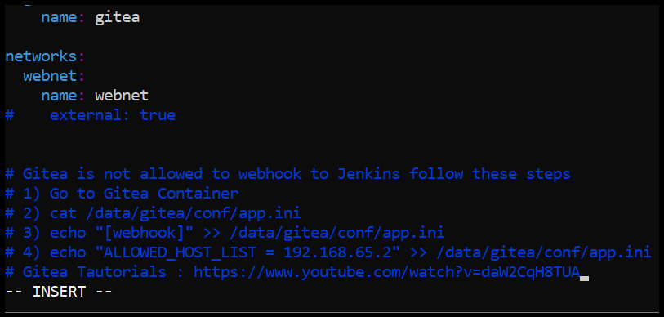
- Compose YAML Saved LS
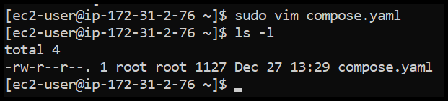
- Usermod And Groups Before After
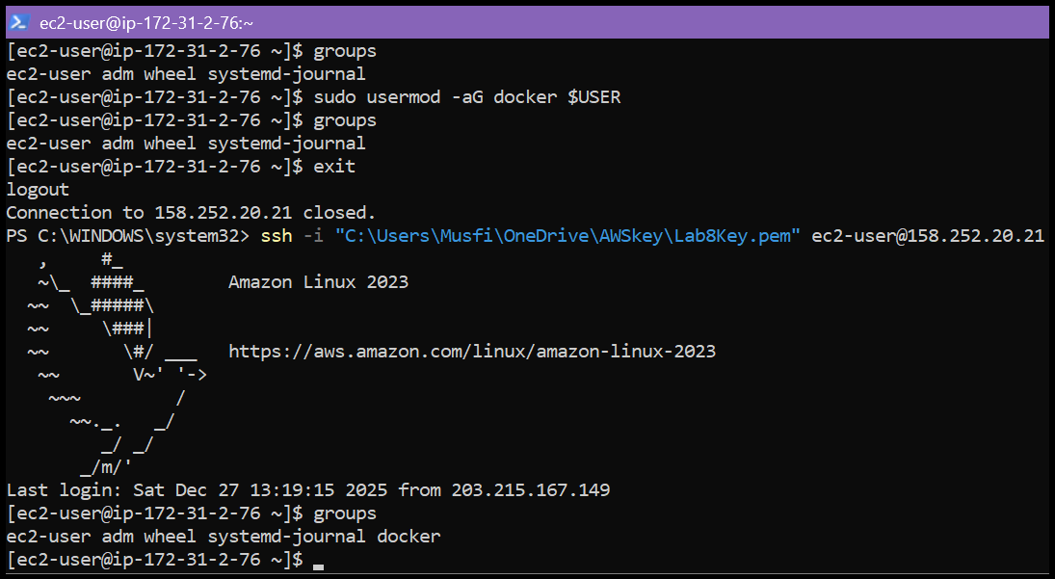
- Docker Compose Up
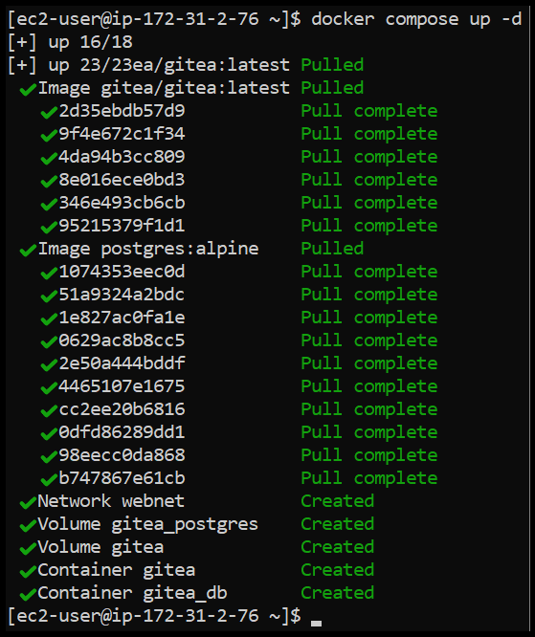
- Security Group Allow 3000
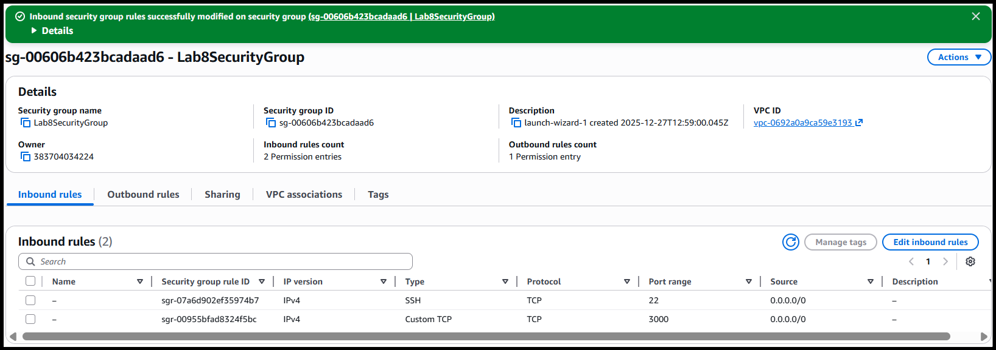
- Gitea Install Page
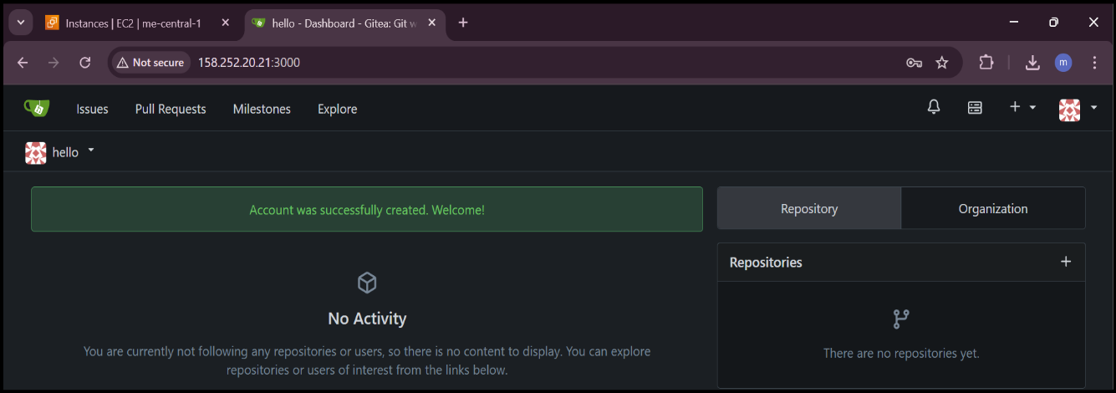
- Gitea Create Repo
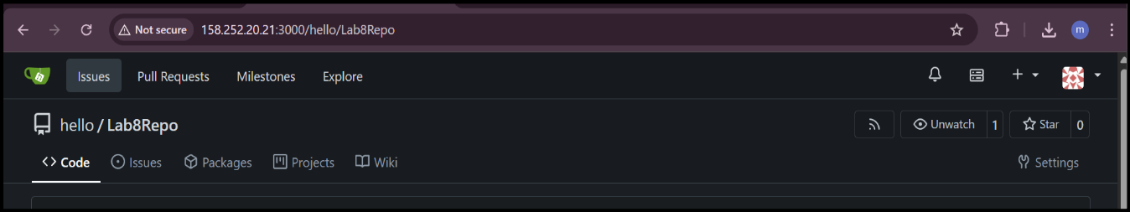
- Summary
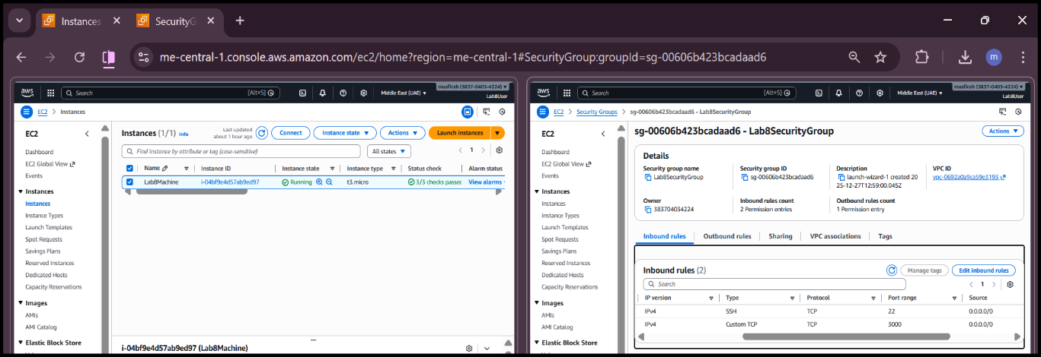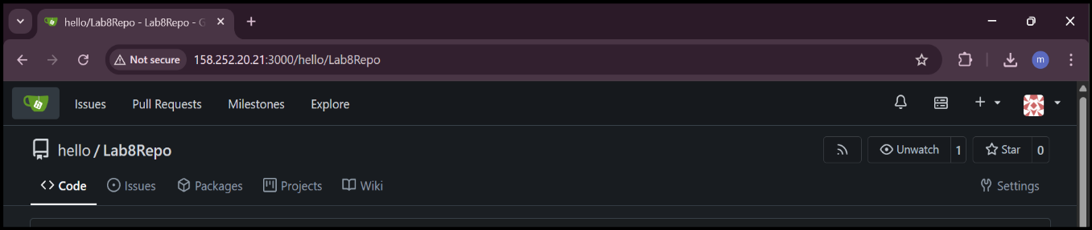
Cleanup — Remove resources to avoid charges
- cleanup_terminate_instance
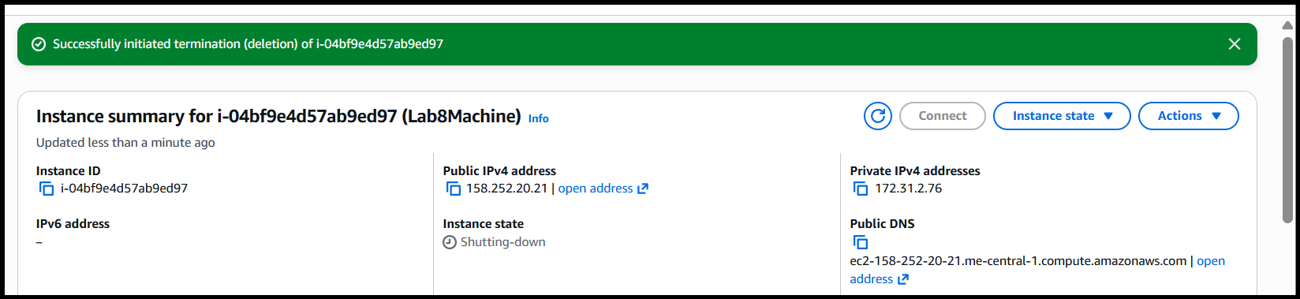
- cleanup_delete_volumes_snapshots
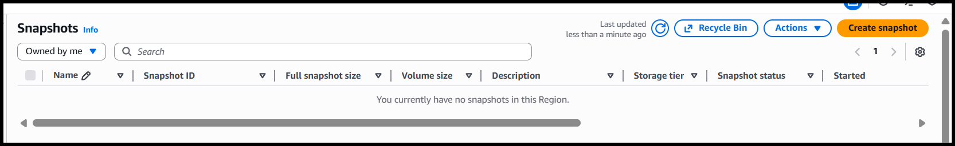
- cleanup_delete_security_group_and_keypair
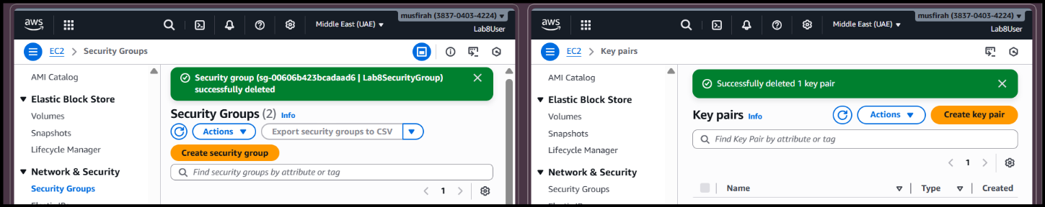
- cleanup_iam_users_deleted
